Skill Test Project: Blue Green Deployment
Git Repo: https://github.com/arunsdpr-wq/Blue-green-Deployment
Npm Installation:
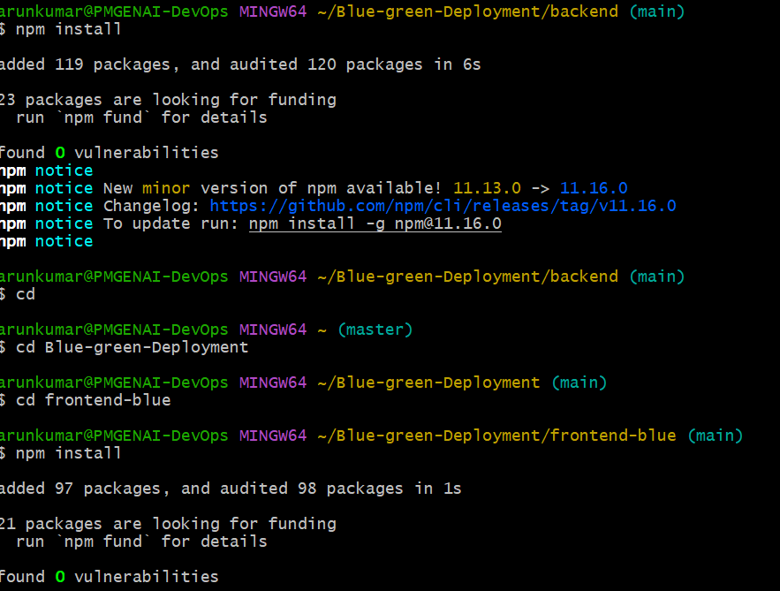
Npm Services started:
For Green
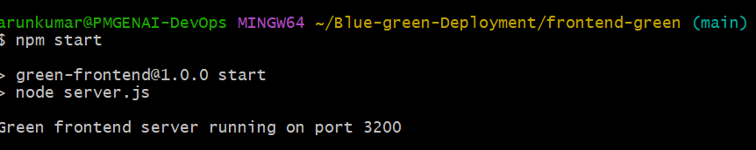

For Mongo DB
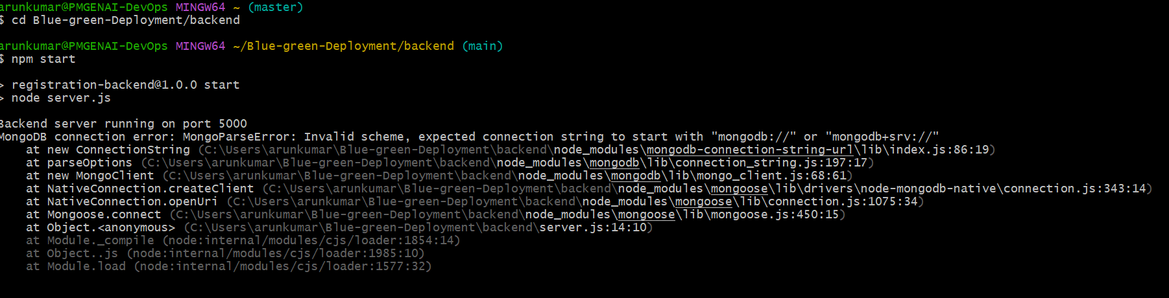

Npm for blue:
